**LIFE EXPECTANCY IN ZIMBABWE**

# **Summary**

* In between 2000 and 2005, life expectancy in Zimbabwe experienced a significant drop of 3.0% attributed to the decline of economic activities
* However, between 2005 and 2015, life expectancy increased by 36.1% to 60.9 from 44.6 years largely driven by formation of a coalition government
* In comparison to other countries, Zimbabwe exhibits very low life expectancy median of approximately 46 with Germany having the highest median life expectancy of approximately 80.0 within the period of 2000 and 2015

# **Introduction**

Life expectancy has been increasing over time in most parts of the world. This increase is mainly driven by, access to better health facilities, improved water facilities, better sanitation, literacy and technological advancements (World Health Organization (WHO), 2005). Albeit, levels of life expectancy increased, a sharp contrast can be viewed between developed and developing countries. In this article, we will focus on one country, Zimbabwe. We will look at overall trend of life expectancy in the country compare to the world. Afterwards, will compare its life expectancy with Chile, China, Germany, Mexico and USA.

# **OVERVIEW OF ZIMBABWE LIFE EXPECTANCY**

Over the decades, inconsistencies have been viewed with the life expectancy in Zimbabwe. While most of the world has exhibited upward trends in the past decades, Zimbabwe recorded irregular trends in life expectancy. In between 2000 and 2005, life expectancy in Zimbabwe experienced a significant drop of 3.0% (see Figure 1) from 46.0 to 44.6, this meant that on average residents lived 1.4 years shorter than in 2000. This decline is largely attributed to the decline of economic activities that in turn led to deterioration of living standards in the country with inflation rate increasing to 585.845 in 2015 from 55.22% in 2000. Poor economic management policies coupled with hyperinflation nearly brought the Zimbabwean economy to its knees. Consequently, there were basic food shortages, decline in education and health care standards which significantly contributed to the decline in life expectancy.

However, between 2005 and 2015, life expectancy increased by 36.1% to 60.9 from 44.6 years. This meant that Zimbabweans lived about 16 years longer than the previous decade. This rise is largely attributed to the formation of Government of National Unity (GNU) which was a coalition of Zimbabwe African National Union-Patriotic Front (ZANU PF) and the two factions of the Movement for Democratic Change (MDC). This stability and national unity brought about by the coalition coupled with the use of foreign currencies, resulted into an overall increase of the countries economic activities. Thus, shops, state hospital and other businesses reopened bringing basic needs commodities back to the market. This in turn improve the mortality in the country.

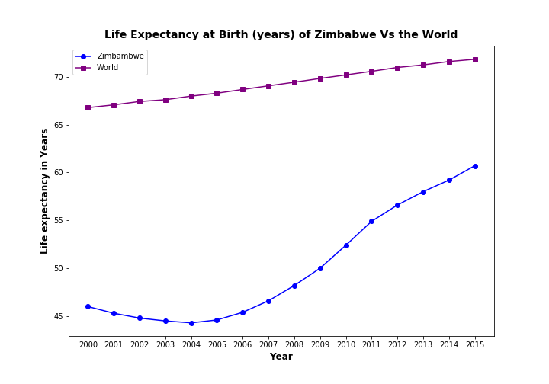

**Figure 1: Life Expectancy at Birth (years) of Zimbabwe V the World**

# **COMPARISON OF ZIMBABWE’S LIFE EXPECTANCY TO OTHER COUNTRIES**

In comparison to other countries, Zimbabwe exhibits very low life expectancy median of approximately 46 with Germany having the highest median life expectancy of approximately 80.0 within the period of 2000 and 2015. Additionally, Zimbabwe’s life expectancy between 2000 and 2015 have reached a low of approximately 44.0 and a high of approximately 60.0. This is in contrast to the rest of the countries with Chile’s low and high coming in at 75.0 and 81.0, China’s at 70.0 and 76.0, Germany’s at 77.0 and 82.0, Mexico’s at 75.0 and 77.0, and America’s at 76.0 and 79.0, respectively.

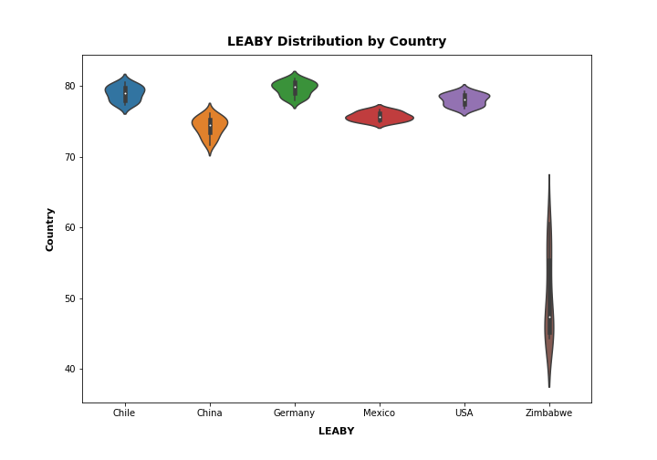

**Figure 2: LEABY Distribution by Country**

Whereas Chile, China, Germany, Mexico, and USA experienced an increase throughout the year of 12.0%, 8.6%, 6.5%, 2.7%, and 3.9%, respectively, Zimbabwe saw a huge drop between the years 2000 and 2005 of 3.0%. Additionally, in figure 3, Zimbabwe exhibits an overall lower life expectancy with 60.9 in 2015, 34.6% lower than Germany which had the highest life expectancy of 82.0. Inconsistencies being viewed in Zimbabwe as opposed to the other countries are as a result of several factors. Such factors include the blowout of HIV, AIDS and other deadly diseases, lack of access to medical facilities as well as the viral spread of poverty in the country as a result of the deteriorating economic activity.

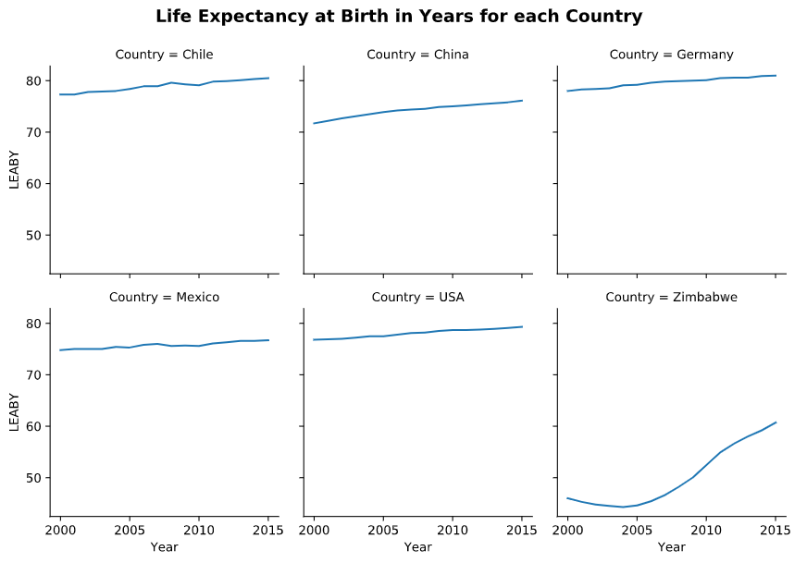

**Figure 3: Life Expectancy at Birth in Years for each Country**